Deagglomeration process of titanium dioxide particles using high shear devices
Radosław Krzosa, Warsaw University of Technology, Warsaw, Poland
Łukasz Makowski, Warsaw University of Technology, Warsaw, Poland
Wojciech Orciuch, Warsaw University of Technology, Warsaw, Poland
Radosław Adamek, ICHEMAD Profarb, Gliwice, Poland
Titanium dioxide has many applications in modern industry and technology. Can be applied in optics industry due to its high refractive index and high durability. Due to its photocatalytic properties titanium dioxide finds application in hydrogen production processes, decomposition of organic compounds and creation of antimicrobial coatings. Large part of titanium dioxide consumption has paint industry because titanium dioxide is used as a white pigment. To obtain specific properties required to each application production process planning and supervising is crucial.
Structure of titanium dioxide available on market consist of agglomerates, large lumps, which compounds are connected to each other via van der Vaals forces, that can be easily disintegrated by hydrodynamic stresses [1]. Agglomerates consist of structures named aggregates, which are formed of primary particles, which are connected by crystal bounds, therefore cannot by broke by hydrodynamic stresses [2]. In preparation process high shear devices generates stresses in titanium dioxide suspension which cause breaking up agglomerates into aggregates, reducing mean size of particles. Devices used in deagglomeration process are high shear impellers, ball mills and rotor stator systems. Sometimes high pressure nozzles and ultrasonication is applied [3,4].
In this study deagglomeration process of titanium dioxide using high shear devices was investigated. Mixing tank equipped with high shear impeller and ball mills were used. For mixing tank different rotational speed and impeller geometries were examinate. For ball mill different milling media volume fraction and shaft rotational speed and flow of nanosuspensions were tested. Results of this study allowed to obtain smaller particle size and reduce deagglomeration time what decreasing energy consumption of the process. Also study of this process allowed to identify breakage mechanism. Application of computational fluid dynamics methods let us better understand the process and find necessary information required for using population balance methods to calculate change of particle size distribution of product during the process.

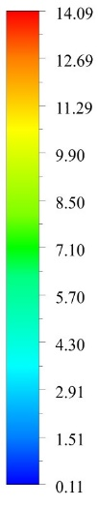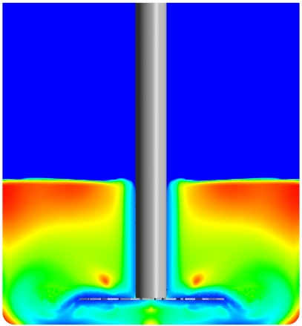
Fig. 1 Contour of apparent viscosity in mixing tank [Pa‧s]

Acknowledgements
This work was supported by ICHEMAD Profarb sp. z o. o. has implemented a project entitled: "Development of utility models for the construction of a set of energy-saving devices for the chemical industry, in particular for the production of paints and varnishes" under Measure 1.1.1 of the Intelligent Development Operational Program 2014-2020 co-financed by the European Regional Development Fund. This study was funded by the “Material Technologies 2 ADVANCED” project of the Warsaw University of Technology under the program Excellence Initiative: Research University. Radosław Krzosa acknowledges also financial support from IDUB project (Scholarship Plus programme).

References
[1] J. Bałdyga, W. Orciuch, Ł. Makowski, M. Malski-Brodzicki, K. Malik, Break up of nano-particle clusters in high-shear devices, Chem. Eng. Process. Process Intensif. (2007). https://doi.org/10.1016/j.cep.2007.05.016.
[2] N.G. Özcan-Taşkin, G. Padron, A. Voelkel, Effect of particle type on the mechanisms of break up of nanoscale particle clusters, Chem. Eng. Res. Des. 87 (2009) 468–473. https://doi.org/10.1016/j.cherd.2008.12.012.
[3] J. Zhang, S. Xu, W. Li, High shear mixers: A review of typical applications and studies on power draw, flow pattern, energy dissipation and transfer properties, Chem. Eng. Process. Process Intensif. 57–58 (2012) 25–41. https://doi.org/10.1016/j.cep.2012.04.004.
[4] N. Mandzy, E. Grulke, T. Druffel, Breakage of TiO2 agglomerates in electrostatically stabilized aqueous dispersions, Powder Technol. 160 (2005) 121–126. https://doi.org/10.1016/j.powtec.2005.08.020.

